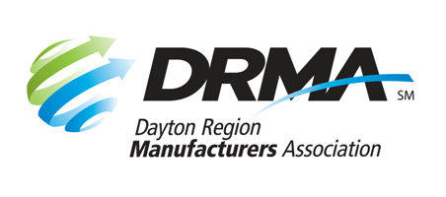

DRMA

Dayton Convention Center

22 E. Fifth St. ● Dayton, OH 45402

P: 937-949-4000 ● F: 937-949-4007

Workforce@DaytonRMA.org ● www.DaytonRMA.org

**CAREER EVENT GIVEAWAYS**

**Sponsor Order Form**

Help grow your future workforce by purchasing a sponsorship of student giveaways! Your sponsorship will help cover the costs of things like lanyards, stickers, dog tags, and wood gliders (all items that students like to get!) that we give to middle and high school students at career events. Your organization’s name will be included.

|  |  |  |
| --- | --- | --- |
| **Opportunity** | **Price** |  |
| Giveaways | $500 | Not available to non-members. |

Specs: DRMA staff will work with you to determine how your name will be promoted, depending on space limitations on the giveaway item.

|  |  |  |  |  |
| --- | --- | --- | --- | --- |
| Company: |  | | Phone: |  |
|  |  | |  |  |
| Contact Name: | |  | Email: |  |
|  | |  |  |  |
| Date Submitted: | |  | Website URL: |  |

|  |  |  |  |  |  |  |  |  |  |  |  |  |  |  |  |  |  |  |  |  |  |
| --- | --- | --- | --- | --- | --- | --- | --- | --- | --- | --- | --- | --- | --- | --- | --- | --- | --- | --- | --- | --- | --- |
| Check (make payable to DRMA) | | | | | | | | | | | Credit card (all major cards accepted) | | | | | | | | | | |
|  | | | | | | | | | | | | | | | | | | | | | |
| **Card #:** |  |  |  |  |  | |  |  | |  | |  |  | |  |  |  | |  |  |  |
| **Exp. Date:** |  | | | | | **CVV Code:** | | |  | | | | | **Billing Zip Code:** | | | |  | | | |
|  |  | | | | | | | | | | | | | | | | | | | | |

**Return this form with payment to the DRMA office.**

If you prefer, you may call the office at 937-949-4000 to place your payment with DRMA staff

**after** you’ve emailed/faxed your form.